"The issue is bigger than geography. It's a public health issue. This is an intrinsically contaminating process and in the end you've caused damage that's irreversible." B. Arrindell

Damascus Citizens for Sustainability (DCS) was launched in the small, rural town of Damascus Pennsylvania in January, 2008; its mission, to raise awareness of, and combat the environmental and community threats posed by the shale gas extraction industry.

Initially focused on protecting the Delaware River Basin that provides drinking water for over 15 million people in NY, NJ, PA, and DE, DCS has been instrumental in keeping hydraulic fracturing out of the Basin for over five years. Working with some of the best and most dedicated environmental attorneys, DCS’s legal action against the Delaware River Basin Commission’s decision to allow “exploratory” gas wells to move forward, resulted in the abrupt withdrawal from the proceedings by the gas industry and their supporters. As a result, further drilling of these vertical test wells was halted.

The fight to keep gas drilling out of the Delaware River Basin (DRB) continued. To
those who said, “It’s coming - you have no choice,” DCS responded:

“We have a choice.”

DCS’ efforts towards public education and our continued pressure on the Delaware
River Basin Commission and legislators has once again brought results, with
Newfield/Hess cancelling their co-owned leases in the Marcellus shale in July. These
two companies pulling out eliminated a large portion of the gas leases in Northeastern
Pennsylvania in the DRB. The companies argued that this was a business decision based
primarily on the current low price of gas, but there is no denying that DCS, with YOUR
support, thwarted their attempts to drill in the Basin for over five years.¹

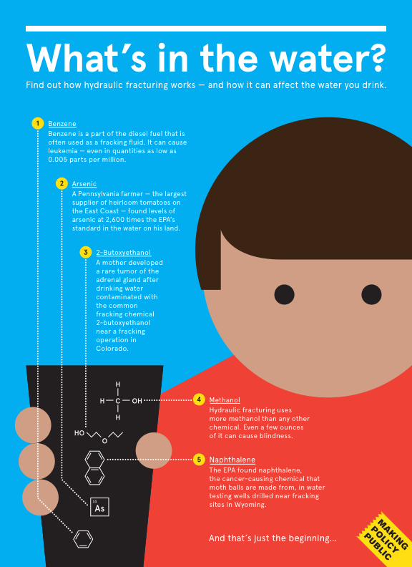

The fight is NOT over
Got your poster?

But we are not “there” yet. Although we have won a very welcome pause in the Delaware River Basin, there is so much more to do. Multiple gas and oil bearing formations, including the Marcellus, are waiting for the next wave of extraction. Our fight to keep the Delaware River Basin frack free, and the endeavor to get help for those already impacted by fracking continues. Enclosed is just one of hundreds of Determination Letters sent by the PA DEP to people whose water has been affected by drilling.

- DCS has been involved in legal efforts to stop gas infrastructure like pipelines and compressors.
- There is an urgent need to inform the public about the risk of cancer from radon which travels with the natural gas extracted from the Marcellus to homes and kitchens.
- Many more areas need the protective “insurance” of a methane baseline. (DCS’ work defining baseline conditions undoubtedly factored into the Newfield/Hess lease cancellations).
- To help communities where public health has been impacted or threatened by gas drilling activity, DCS launched a comprehensive Health and Community Impacts Survey that gives households an official place to record information that will be invaluable for Public Health Assessments.

HELP US DO MORE!

The passion and commitment of our volunteers and supporters is extraordinary, but we need your financial support to continue our important work. Please help us at this critical juncture by making a generous donation to support continued progress on initiatives like the following:

• Keeping radon out of our homes. The first to raise the alarm about gas drilling on the East Coast, DCS was also the first to raise the alarm on the radioactivity in the Marcellus that moves with solid and liquid wastes from drilling and with the gas itself (as radon) to end users in amounts 30 to 80 times (or more) higher than the current level- a specific threat to NYC as pipelines are completed to convey Marcellus gas to the City. It has also raised the alarm about radioactive contaminants in drill cuttings (solid wastes) which the industry is disposing of in New York landfills. DCS has spearheaded public, broad based coalition calls for hearings on the issue, exceptional seminars and educating policy makers; so that now there is legislation moving forward in New York State to monitor and limit the radon levels in gas entering NYC.

• Keeping the focus on health impacts. In New York State, we are helping to maintain pressure on Governor Cuomo and his Department of Health with public health concerns that have been a principle DCS focus from our inception.

• Fighting for local zoning control over gas drilling. DCS helped bring about the 2009 Pennsylvania Supreme Court decision that upheld this right. Governor Corbett is now attempting to supersede that judgment with legislation in Act 13. Working with a long list of environmental organizations, legal challenges have been mounted to parts of Act 13 harmful to local control. Further legal actions by DCS are anticipated in the pivotal year ahead in PA and other venues.

• Amassing official data on, and getting help for, adverse impacts of natural gas drilling. The Natural Gas Exploration and Production Health & Community Impacts Survey² , which includes a Petition for a Public Health Assessment to the Agency for Toxic Substances and Disease Registry (ATSDR), a division of the Centers for Disease Control, is the first effort to officially record and track public health issues in areas impacted by gas activities. Tracking these issues in a Federal database lays the groundwork for affected communities to get help.

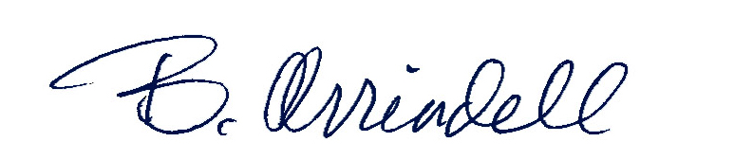
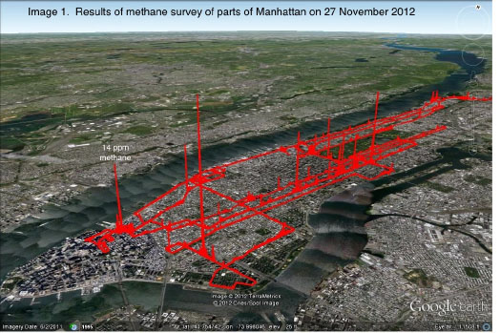
• Innovative, reliable scientific studies commissioned by DCS measuring methane baselines have been done in several municipalities³, using court-admissible laser technology . Once the baseline amount of methane has been established, it will be tough for a gas company to claim a sudden spike in methane in an area is unrelated to drilling activity. DCS has also measuremed methane in areas⁴ impacted by drilling, which quantifies impacts the companies are denying. Bill McKibben (350.org) recognized our
Manhattan methane emissions
work measuring the methane escaping in Manhattan that is
impacting the planet⁵. This work is being done to show that the
“clean” gas is actually just another dirty fossil fuel. We must move
to renewable energy sources.

With your help we will prevail.

B. Arrindell, Director
Please make a contribution today! USE PAYPAL / CREDIT CARD
DONATE BUTTON www.DamascusCitizens.org
...or send a check to: DCS• P.O.Box147• Milanville, PA 18443

Damascus Citizens for Sustainability is a 501c3 tax exempt, non-profit and your contribution is fully tax deductible.
Got your poster? Anyone who asks for one and all who donate can be sent a “What’s In The Water” poster that explains all the gas drilling processes and all the impacts.

¹ http://www.damascuscitizensforsustainability.org/2013/07/fracktivists-celebrate-cancellation-of-gas-leases-in-ne-pa/
² Natural Gas Exploration and Production Health & Community Impacts Survey http://www.damascuscitizensatsdr.org/
³ Baseline work example -http://www.damascuscitizensforsustainability.org/2012/11/damascus-baseline/
⁴ Responses to events work http://www.damascuscitizensforsustainability.org/2012/09/new-report-questions-pa-environmental-chiefs-assertion-about-methane-contamination/
⁵ Manhattan Methane Emissions work http://www.damascuscitizensforsustainability.org/2013/03/manhattan-natural-gas-pipeline-emissions-press-release/

